Speedometer modelspoorbaan

Eddy Luursema, 18 februari 2022

Inleiding

In dit document wordt een eenvoudige snelheidsmeter voor de modelspoorbaan beschreven. Voor pakketten voor modelspoorbaanbesturing zoals WinDigipet en Traincontroller is een nauwkeurige ijking tussen ingestelde en daadwerkelijke snelheid noodzakelijk om een trein (locomotief) tot op de centimeter ergens te laten stoppen. Die pakketten rekenen in km/h voor de snelheid, maar in centimeters (in combinatie met de op te geven schaal) voor spoorlengtes.

De speedometer is gebaseerd op een eenvoudige Arduino Nano met twee infrarood lichtsluizen. Via meerdere kleine losse projecten wordt de uiteindelijke speedometer opgebouwd.

Materiaallijst

|  |  |  |  |
| --- | --- | --- | --- |
| Onderdeel | Aantal | Link | Prijs/stuk |
| Arduino Nano | 1 | <https://www.tinytronics.nl/shop/nl/development-boards/microcontroller-boards/arduino-compatible/nano-v3.0-compatible> | €6 |
| IR onderbrekingssensor | 2 | <https://www.tinytronics.nl/shop/nl/sensoren/optisch/infrarood/infrarood-onderbrekingssensor> | €3,50 |
| Drukknop | 2 | <https://www.tinytronics.nl/shop/nl/schakelaars/manuele-schakelaars/drukknoppen-en-schakelaars/drukknop-module-rood> | €1,25 |
| OLED scherm | 1 | [https://www.tinytronics.nl/shop/nl/displays/oled/0.91-inch-oled-display-128*32-pixels-wit-i2c](https://www.tinytronics.nl/shop/nl/displays/oled/0.91-inch-oled-display-128*32-pixels-wit-i2c) | €6,50 |
| Print | 1 | [https://www.tinytronics.nl/shop/nl/gereedschap-en-montage/prototyping-toebehoren/experimenteer-printplaten/experimenteer-printplaat-7cm*9cm-dubbele-eilandjes](https://www.tinytronics.nl/shop/nl/gereedschap-en-montage/prototyping-toebehoren/experimenteer-printplaten/experimenteer-printplaat-7cm*9cm-dubbele-eilandjes) | €0,65 |
| Schroefconnector 2 klemmen | 3 | <https://www.tinytronics.nl/shop/nl/kabels-en-connectoren/connectoren/schroefterminals/2-pin-schroef-terminal-block-connector-5.08mm-afstand> | €0,75 |
| Headers 30 pins | 1 | <https://www.tinytronics.nl/shop/nl/kabels-en-connectoren/connectoren/pin-headers/female/40-pins-header-female> | €0,50 |
| Draadjes |  |  |  |
| Adereindhulzen | 10 |  |  |
| Schroefjes/moertjes | 9 |  |  |
| Afstandsbussen | 5 |  |  |
| Multiplex plaat 40*8 cm | 1 |  |  |
| Plankjes 70*11 mm | 4 |  |  |
| Totaal |  |  | €24-30 |

Elektrisch schema

Constructie

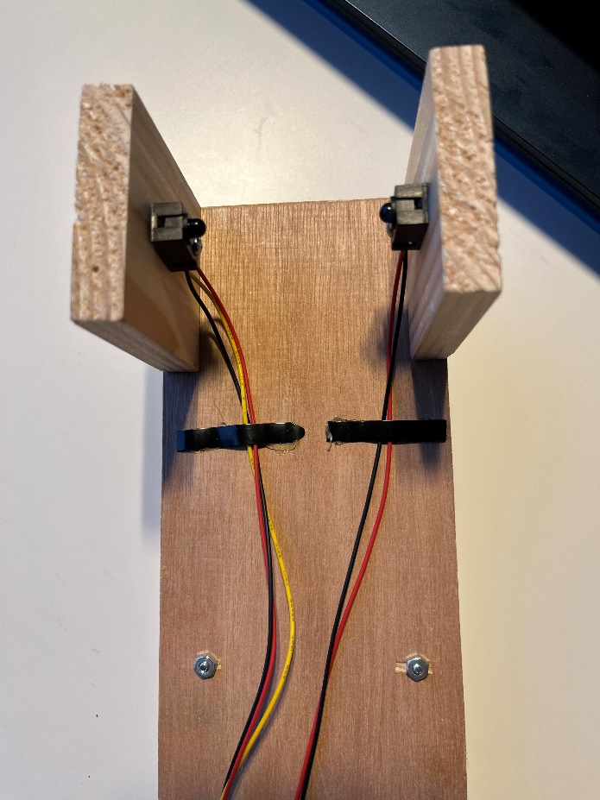

Snelheid op modelspoorbaan berekenen

Gegeven dat een locomotief op een modelspoorbaan een bepaalde afstand L aflegt in T milliseconde betekent dat de locomotief rijdt met een snelheid van:

S = L / T mm/ms (millimeter / milliseconde)

S = L / T / 1000 m/ms

S = L / T m/s

1 km/h = 1000 / 3600 m/s dus 1 m/s = 3.6 km/h

S = L / T * 3.6 km/h

Bij een schaal N met een verhouding 1:160 rijdt de locomotief dus in werkelijkheid een factor 160 sneller dus

S = L /T * 3.6 * 160 km/h

Testen werking lichtsluizen

Attentie: in de documentatie van de leverancier <https://www.tinytronics.nl/shop/nl/sensoren/optisch/infrarood/infrarood-onderbrekingssensor> staat vermeld dat een pullup-weerstand van 1-10 kΩ nodig is; de interne pullup van een Arduino is volgens [https://www.arduino.cc/en/Tutorial/Foundations/DigitalPins 20-50](https://www.arduino.cc/en/Tutorial/Foundations/DigitalPins%2020-50) kΩ. Daarom is een externe pullup -weerstand noodzakelijk.

|  |
| --- |
| /*  Simple IR gateway detector, built in LED will respond to IR gateway  */  const int PIN **=** 12**;**  void setup**()** **{**  pinMode**(**LED_BUILTIN**,** OUTPUT**);;**  pinMode**(**PIN**,** INPUT_PULLUP**);**  Serial**.**begin**(**9600**);**  **}**  void loop**()** **{**  int value **=** digitalRead**(**PIN**);**  digitalWrite**(**LED_BUILTIN**,**value**);**  **}** |

Dit programma is vooral handig om de werking te testen, maar ook als de sluis fysiek met plankjes gemonteerd moet worden om te controleren of de LED en detector recht tegenover elkaar staan. Verander de constante PIN afhankelijk van de te controleren sluis.

Meten snelheid van L naar R met twee sensoren

Bestand **speedMeasurementFunction.ino** is een library met een functie om de snelheid te berekenen. De twee elkaar opheffende stappen met mm en ms zijn commentaar geworden.

|  |
| --- |
| //const int MILLISPERSECOND = 1000;  //const int MILLIMETERPERMETER = 1000;  const float METERPERSECONDTOKMH **=** 3.6**;**  float calculateSpeed**(**int sensorLength**,** long intervalMillis**,** int modelScale**)** **{**  float speed **=** sensorLength **/** float**(**intervalMillis**);** // mm per msec  //speed = speed / MILLIMETERPERMETER; // m per msec  //speed = speed * MILLISPERSECOND; // m/s  speed **=** speed **\*** METERPERSECONDTOKMH**;** // km/h  speed **=** speed **\*** modelScale**;** // km/h in real scale  **return** speed**;**  **}** |

|  |
| --- |
| /*  Simple speed measuring system for model train control using two IR gateways  Only suited for detection from L to R  */  const int modelScale **=** 160**;** //the scale the model train is built in e.g. 1:160. Not a constant; can be changed later on  const int sensorLength **=** 200**;** //the distance between the sensors in mm  const int LEFTPIN **=** 12**;**  const int RIGHTPIN **=** 11**;**  long previousMillis**;**  void setup**()** **{**  pinMode**(**LEFTPIN**,** INPUT_PULLUP**);**  pinMode**(**RIGHTPIN**,** INPUT_PULLUP**);**  Serial**.**begin**(**9600**);**  **}**  void loop**()** **{**  **while** **(**digitalRead**(**LEFTPIN**)** **!=** 0**)** **{** //simple example wait for left sensor to be activated  **}**  previousMillis **=** millis**();**  **while** **(**digitalRead**(**RIGHTPIN**)** **!=** 0**)** **{** //simple example wait for right sensor to be activated  **}**  long intervalMillis **=** millis**()** **-** previousMillis**;**  float speed **=** calculateSpeed**(**sensorLength**,** intervalMillis**,** modelScale**);**  Serial**.**print**(**"Speed is "**);**  Serial**.**print**(**speed**);**  Serial**.**println**(**" km/h"**);**  **}** |

De snelheid is redelijk constant van deze dieselloc de BR204 van Fleischmann en ligt tussen de 121.93 en 122.30 km/h.

Met dit prototype kan prima worden gewerkt als van L->R wordt gereden en de schaal vast staat.

Lichtsluis tijdsmeting

Omdat het onbekend is of er door het onderbreken van de lichtstraal contactdender kan ontstaan net als bij een drukknop zijn met een eenvoudige logic analyzer de signalen van links en rechts bekeken en nagemeten of de tijd klopt met die in de software:

Links naar rechts op de voorzijde van de loc 1.653 ms zou betekenen

Op de achterzijde 1.650 ms:

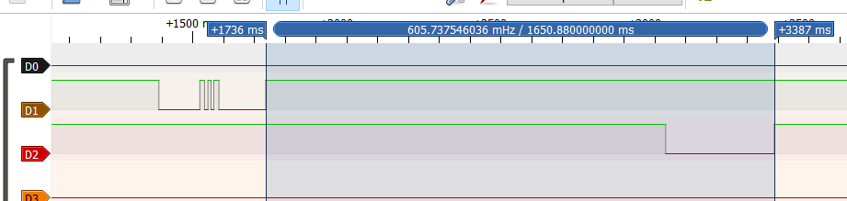

**Echter er brandden op de gebruikte baan een aantal rode seinen; deze geven zoals zal blijken helaas ook infrarode straling af.** Deze seinen zijn nu uitgeschakeld; dit was mogelijk omdat de seindecoders zo zijn ingesteld dat deze geen seinbeelden geven, maar de individuele LED’s afzonderlijk bestuurbaar zijn.

De glitch links is verdwenen door het uitschakelen van het sein.

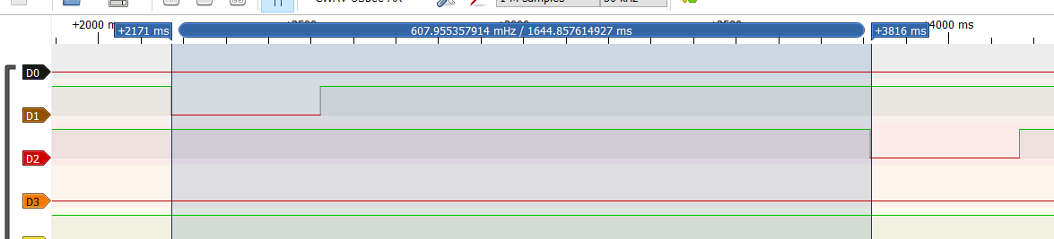

Aansturen OLED

Aangeschaft bij Tinytronics de [https://www.tinytronics.nl/shop/nl/displays/oled/1.3-inch-oled-display-128*64-pixels-wit-i2c](https://www.tinytronics.nl/shop/nl/displays/oled/1.3-inch-oled-display-128*64-pixels-wit-i2c) voor €8,- met als ingebouwde controller de SSH1106.

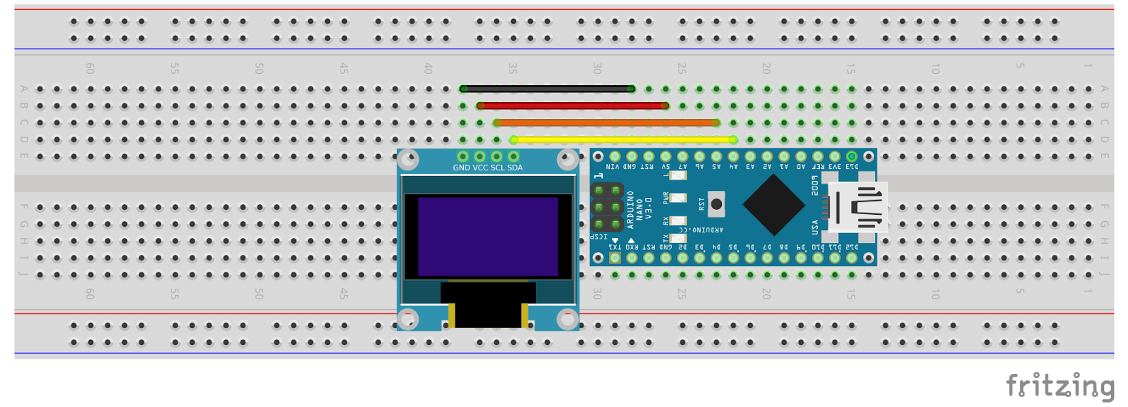

Uit: <https://create.arduino.cc/projecthub/Arnov_Sharma_makes/0-96-inch-oled-getting-started-guide-78163a>. Helaas bestaan er ontzettend veel verschillende OLED- en LCD-controllers, die in veel gevallen uitgerust zijn met de SSD1306. Er moet dus ook een library toegepast worden en die van de SSH1106 en SSD1306 zijn **niet** compatibel. Op de website van Tinytronics staat een verwijzing naar een SSH1106-library <https://github.com/olikraus/U8g2_Arduino>. Op zich werkt deze library, maar die heeft ontzettend veel grafische componenten waardoor na compilatie bijna 24k programmageheugen is verbruikt. Daarom is gekeken naar een kleinere library: <https://github.com/notisrac/SH1106Lib>

Op schaalgrootte 2 moeten wat concessies worden gedaan t.a.v. het aantal tekens op één regel:

|  |
| --- |
| /*********  Rui Santos  Complete project details at https://randomnerdtutorials.com  Adapted for train by Eddy  *********/  #include <Wire.h>  #include <Adafruit_GFX.h>  #include <Adafruit_SSD1306.h>  #define SCREEN_WIDTH 128 // OLED display width, in pixels  #define SCREEN_HEIGHT 32 // OLED display height, in pixels  // Declaration for an SSD1306 display connected to I2C (SDA, SCL pins)  Adafruit_SSD1306 display**(**SCREEN_WIDTH**,** SCREEN_HEIGHT**,** **&**Wire**,** **-**1**);**  void setup**()** **{**  Serial**.**begin**(**115200**);**  **if** **(!**display**.**begin**(**SSD1306_SWITCHCAPVCC**,** 0x3C**))** **{** // Address 0x3D for 128x64  Serial**.**println**(**F**(**"SSD1306 allocation failed"**));**  **for** **(;;);**  **}**  delay**(**2000**);**  display**.**clearDisplay**();**  display**.**setTextSize**(**2**);** //size 2 does work with less letters  display**.**setTextColor**(**WHITE**);**  display**.**setCursor**(**0**,** 0**);**  display**.**println**(**"N 123.4kmh"**);**  display**.**setCursor**(**0**,** 17**);**  display**.**println**(**"432.1 #999"**);**  display**.**display**();**  **}**  void loop**()** **{**  **}** |

Omschakelen schaal

Het bestand **controlScale_Functions.ino** bevat library voor omzetten en printen van de aschaal

|  |
| --- |
| // Function to set new scale given old one. There no such thing as getting the next in an enum  int setNextScale**(**int oldScaleSetting**)** **{**  int returnValue**;**  **switch** **(**oldScaleSetting**)** **{**  **case** G**:** returnValue **=** O**;**  **break;**  **case** O**:** returnValue **=** S**;**  **break;**  **case** S**:** returnValue **=** H0**;**  **break;**  **case** H0**:** returnValue **=** N**;**  **break;**  **case** N**:** returnValue **=** Z**;**  **break;**  **case** Z**:** returnValue **=** G**;**  **break;**  **}**  **return** returnValue**;**  **}**  // Function to print the scale. There is no easy way to print enum contents  void printScale**(**int currentScale**)** **{**  String scaleLetter**;**  **switch** **(**currentScale**)** **{**  **case** G**:** scaleLetter **=** "G"**;**  **break;**  **case** O**:** scaleLetter **=** "O"**;**  **break;**  **case** S**:** scaleLetter **=** "S"**;**  **break;**  **case** H0**:** scaleLetter **=** "H0"**;**  **break;**  **case** N**:** scaleLetter **=** "N"**;**  **break;**  **case** Z**:** scaleLetter **=** "Z"**;**  **break;**  **}**  Serial**.**print**(**scaleLetter**);**  **}** |

|  |
| --- |
| /*  Simple control example setting the scale of the system using a button  */  enum SCALE **{**G **=** 24**,** O **=** 48**,** S **=** 64**,** H0 **=** 87**,** N **=** 160**,** Z **=** 220**};**  SCALE scaleSetting**;** //actual scale set  const int CONTROLPIN **=** 11**;**  void setup**()** **{**  pinMode**(**CONTROLPIN**,** INPUT_PULLUP**);**  scaleSetting **=** N**;**  Serial**.**begin**(**9600**);**  **}**  void loop**()** **{**  **while** **(**digitalRead**(**CONTROLPIN**)** **!=** 1**)** **{** //simple example wait for button to be activated  **};**  scaleSetting **=** setNextScale**(**scaleSetting**);**  delay**(**10**);**  **while** **(**digitalRead**(**CONTROLPIN**)** **!=** 0**)** **{** //simple example wait for button to be deactivated  **};**  delay**(**10**);**  Serial**.**print**(**"scale: "**);**  printScale**(**scaleSetting**);**  Serial**.**println**();**  **}** |

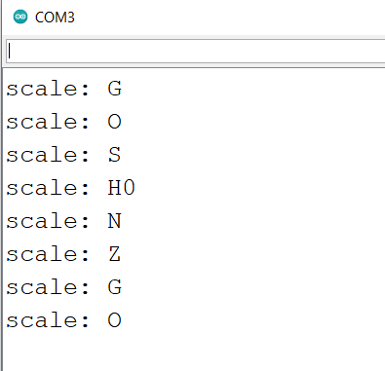

Project 4 OLED schermbesturing

Speedometer

speedCalculationFunction.ino

|  |
| --- |
| /*  Calculates speed of loc given the time interval passing two IR gateways according to scale and length of gateway  */  //const float MILLISPERSECOND = 1000.0;  //const float MILLIMETERPERMETER = 1000.0;  const float METERPERSECONDTOKMH **=** 3.6**;**  float calculateSpeed**(**float sensorLength**,** long intervalMillis**,** int modelScale**)** **{**  float speed **=** sensorLength **/** float**(**intervalMillis**);** // mm per msec  //speed = speed / MILLIMETERPERMETER; // m per msec  //speed = speed * MILLISPERSECOND; // m/s  speed **=** speed **\*** METERPERSECONDTOKMH**;** // km/h  speed **=** speed **\*** float**(**modelScale**);** // km/h in real scale  **return** speed**;**  **}** |

irGateWay.ino

|  |
| --- |
| /*  All the setup and functions needed to use the two interrupt pins to detect the passing of the IR gateway  */  const int LEFTPIN **=** 2**;** //interrupt capable pin must be 2 or 3 on a Arduino Uno/Nano  const int RIGHTPIN **=** 3**;** //interrupt capable pin must be 2 or 3 on a Arduino Uno/Nano  void setupIRGateWay **()** **{**  pinMode**(**LEFTPIN**,** INPUT_PULLUP**);**  pinMode**(**RIGHTPIN**,** INPUT_PULLUP**);**  attachInterrupt**(**digitalPinToInterrupt**(**LEFTPIN**),** interruptLeft**,** FALLING**);** //IR gateway goes to LOW when IR is blocked  attachInterrupt**(**digitalPinToInterrupt**(**RIGHTPIN**),** interruptRight**,** FALLING**);**  **}**  void interruptLeft**()** **{**  currentMillis **=** millis**();** //directly after interrupt to assure accurate measurement  **if** **(**passState **==** NONE**)** **{** //if there would be second interrupt due to bouncing effect of IR gateway, no problem.  passState **=** LEFTIN**;** //loc is coming from left, save that  printDirection **=** **true;** //signal main program loop to print direction only once  previousMillis **=** currentMillis**;** //time of entrance is saved  **}** **else** **if** **(**passState **==** RIGHTIN**)** **{** //loc came from right and is now leaving left, start calculation  intervalMillis **=** currentMillis **-** previousMillis**;** //intervalmillis <> 0 means main program loop must print it  passState **=** NONE**;**  **}**  **}**  void interruptRight**()** **{**  currentMillis **=** millis**();** //directly after interrupt to assure accurate measurement  **if** **(**passState **==** NONE**)** **{** //if there would be second interrupt due to bouncing effect of IR gateway, no problem.  passState **=** RIGHTIN**;** //loc is coming from left, save that  printDirection **=** **true;** //signal main program loop to print direction only once  previousMillis **=** currentMillis**;** //time of entrance is saved  **}** **else** **if** **(**passState **==** LEFTIN**)** **{** //loc came from left and is now leaving right, start calculation  intervalMillis **=** currentMillis **-** previousMillis**;** //intervalmillis <> 0 means main program loop must print it  passState **=** NONE**;**  **}**  **}** |

controlScale_Functions

|  |
| --- |
| /*  Functions to alter and to print the scale of the speedometer  */  SCALETYPE setNextScale**(**SCALETYPE oldScaleSetting**)** **{** //given current scale, return next scale.  SCALETYPE returnValue**;**  **switch** **(**oldScaleSetting**)** **{**  **case** G**:** returnValue **=** O**;** //Attention sequence in case statement must match enum sequence in main program  **break;**  **case** O**:** returnValue **=** S**;**  **break;**  **case** S**:** returnValue **=** H0**;**  **break;**  **case** H0**:** returnValue **=** N**;**  **break;**  **case** N**:** returnValue **=** Z**;**  **break;**  **case** Z**:** returnValue **=** G**;**  **break;**  **}**  **return** returnValue**;**  **}**  String printScale**(**SCALETYPE currentScale**)** **{**  String scaleLetter**;**  **switch** **(**currentScale**)** **{**  **case** G**:** scaleLetter **=** "G"**;**  **break;**  **case** O**:** scaleLetter **=** "O"**;**  **break;**  **case** S**:** scaleLetter **=** "S"**;**  **break;**  **case** H0**:** scaleLetter **=** "H0"**;**  **break;**  **case** N**:** scaleLetter **=** "N"**;**  **break;**  **case** Z**:** scaleLetter **=** "Z"**;**  **break;**  **}**  **return** scaleLetter**;**  **}** |

OLED

|  |
| --- |
| /*  All the setup and functions needed to use the OLED screen  Print is scalable in several sizes. With size 2 compromises are made in number of characters shown  */  #include <Wire.h>  #include <Adafruit_GFX.h>  #include <Adafruit_SSD1306.h>  #define SCREEN_WIDTH 128 // OLED display width, in pixels  #define SCREEN_HEIGHT 32 // OLED display height, in pixels  // Declaration for an SSD1306 display connected to I2C (SDA, SCL pins)  Adafruit_SSD1306 display**(**SCREEN_WIDTH**,** SCREEN_HEIGHT**,** **&**Wire**,** **-**1**);**  void setupOLED **()** **{**  **if** **(!**display**.**begin**(**SSD1306_SWITCHCAPVCC**,** 0x3C**))** **{** // Address 0x3D for 128x64  Serial**.**println**(**F**(**"SSD1306 allocation failed"**));**  **for** **(;;);**  **}**  display**.**clearDisplay**();**  display**.**setTextSize**(**1**);**  display**.**setTextColor**(**WHITE**);**  display**.**setCursor**(**0**,** 0**);**  display**.**println**(**"Speedometer V0.1"**);** //print program, version and author  display**.**setCursor**(**0**,** 17**);**  display**.**println**(**"Eddy Luursema"**);**  display**.**display**();**  delay**(**4000**);**  **}**  void printOutput**(**int scaleSetting**,** float currentSpeed**,** float averageSum**,** int averageCount**,** state passState**)** **{**  String outputOLED**;**  display**.**clearDisplay**();**  display**.**setTextSize**(**2**);**  display**.**setTextColor**(**WHITE**);**  display**.**setCursor**(**0**,** 0**);**  outputOLED **=** outputOLED **+** printScale**(**scaleSetting**)** **+** " "**;**  **if** **(**passState **!=** NONE**)** **{**  **if** **(**passState **==** LEFTIN**)** **{**  outputOLED **=** outputOLED **+** ">> "**;**  **}** **else** **{**  outputOLED **=** outputOLED **+** "<< "**;**  **}**  **}** **else** **{**  outputOLED **=** outputOLED **+** String**(**currentSpeed**,** 1**);**  **if** **(**outputOLED**.**length**()** **>** 6**)** **{** //string does not fit with km/h so print kmh  outputOLED **=** outputOLED **+** "kmh"**;**  **}** **else**  outputOLED **=** outputOLED **+** "km/h"**;**  **}**  display**.**print**(**outputOLED**);**  display**.**setCursor**(**0**,** 17**);**  **if** **(**averageCount **>=** 1**)** **{** //average can be calculated  display**.**print**(**averageSum **/** averageCount**);**  display**.**print**(**" "**);**  display**.**print**(**"#"**);**  display**.**print**(**averageCount**);**  **}**  display**.**display**();**  **}** |

Buttons.ino

|  |
| --- |
| /*  All the setup and functions needed to use the two buttons with deboucing. Software is capable of handling more buttons  */  int buttonPins**[**NRBUTTONS**]** **=** **{**A0**,** A1**};** //pins to which buttons are connected  long buttonActionMillis**[**NRBUTTONS**];** //time first action on given button  const int DEBOUNCE **=** 10**;** //10 msec for debouncing  void setupButtons**()** **{**  **for** **(**int button **=** 0**;** button **<** NRBUTTONS**;** button**++)** **{**  pinMode**(**buttonPins**[**button**],** INPUT_PULLUP**);** //set pin to input  buttonStates**[**button**]** **=** OPEN**;** //button state is default not pressed  **}**  **}**  void testButtons**()** **{**  **for** **(**int button **=** 0**;** button **<** NRBUTTONS**;** button**++)** **{** //wal;k through all buttons  **if** **((**buttonStates**[**button**]** **==** OPEN**)** **&&** **(**digitalRead**(**buttonPins**[**button**])** **==** 0**))** **{** //was button pressed?  buttonStates**[**button**]** **=** ACTION**;** //this state is used as semaphore between this function and main loop  buttonActionMillis**[**button**]** **=** millis**();** //save moment of first press  **}** **else** **if** **((**buttonStates**[**button**]** **==** TOCLOSE**)** **&&**  **(**millis**()** **-** buttonActionMillis**[**button**]** **>** DEBOUNCE**))** **{** //button was closing and debounce time has passed?  buttonStates**[**button**]** **=** CLOSED**;** //button is now officially closed  **}** **else** **if** **((**buttonStates**[**button**]** **==** CLOSED**)** **&&** //button is opening?  **(**digitalRead**(**buttonPins**[**button**])** **==** 1**))** **{**  //button pressed first time  buttonStates**[**button**]** **=** TOOPEN**;**  buttonActionMillis**[**button**]** **=** millis**();**  **}** **else** **if** **((**buttonStates**[**button**]** **==** TOOPEN**)** **&&**  **(**millis**()** **-** buttonActionMillis**[**button**]** **>** DEBOUNCE**))** **{** //button was opening and debounce time has passed?  buttonStates**[**button**]** **=** OPEN**;** //button is now officially opened  **}**  **}**  **}**  BUTTONSTATE getButtonState**(**BUTTONTYPE button**)** **{**  **return** buttonStates**[**button**];**  **}** |

|  |
| --- |
| /*  Speedometer by Eddy Luursema 2022 Febrary    Simple speed measuring system for model train control using two IR gatesways, two buttons and an OLED  This example uses interrupts on pin2 and 3 of the Atmel386P which can be configured for interrupts for a locomotive coming from left of right  */  enum SCALETYPE **{**G **=** 24**,** O **=** 48**,** S **=** 64**,** H0 **=** 87**,** N **=** 160**,** Z **=** 220**};** //these are the scales system supports, adding a new one means also change controlScaleFunctions.ino  SCALETYPE scaleSetting**;** //actual scale that is set  const int NRBUTTONS **=** 2**;** //system has two buttons  int buttonStates**[**NRBUTTONS**];** //buttonstate is used to prevent bouncing but also as semaphore  enum BUTTONTYPE **{**SCALEBUTTON**,** RESETBUTTON**};** //name of the buttons in this program  enum BUTTONSTATE **{**OPEN**,** ACTION**,** TOCLOSE**,** CLOSED**,** TOOPEN**};** //button can be open, closed, bouncing from open to close or open and action  const float sensorLength **=** 348.0**;** //the distance between the sensors in mm specific for each construction  enum state **{**NONE**,** LEFTIN**,** RIGHTIN**};** //possible statuses of the loc being outside the gateway, entered from left or entered from right  volatile state passState**;** //catual status of the loc; is volatile because is used as semaphore  const int GLITCH **=** 30000**;** //the loc must pass in 30 seconds or passing of IR will be treated as a glitch and loc is supposed to be outside  long previousMillis**;** //timestamp of previous passing  long currentMillis**;** //timestamp of previous passing  long intervalMillis**;** //interval of passing two IR-gateways  float currentSpeed**;** //calculated speed according to scale  float averageSpeed**;** //average speed over multiple measurements; button can reset average  int averageCount**;** //number of measurements  volatile bool printDirection**;** //indication that main program must print direction; is volatile because is used as semaphore  void setup**()** **{**  setupButtons**();** //initialise input ports  setupOLED**();** //initialise OLED; show hello for a few seconds  setupIRGateWay**();** //initialise IR input ports and interrupts  scaleSetting **=** N**;** //my track is scale N so that is the default  passState **=** NONE**;** //start without locomotive between gateways  printDirection **=** **false;** //used as semaphore between interrupt routine and main loop. If true print direction  intervalMillis **=** 0**;** //used as semaphore between interrupt routine and main loop. If unequal 0 print interval and speed  averageSpeed **=** 0.0**;**  averageCount **=** 0**;**  printOutput**(**scaleSetting**,** 0**,** averageSpeed**,** averageCount**,** passState**);** //print scale and average zero  **}**  void loop**()** **{**  testButtons**();** //test if any button is pressed  **if** **(**buttonStates**[**SCALEBUTTON**]** **==** ACTION**)** **{** //scale button pressed?  scaleSetting **=** setNextScale**(**scaleSetting**);** //set the next scale and print it  printOutput**(**scaleSetting**,** currentSpeed**,** averageSpeed**,** averageCount**,** NONE**);**  buttonStates**[**SCALEBUTTON**]** **=** TOCLOSE**;** //semaphore: button pressed was detected by function testButtons. Main loop handles action and set state to TOCLOSE so function testButtons can catch debounce  **}**  **if** **(**buttonStates**[**RESETBUTTON**]** **==** ACTION**)** **{** //reset button pressed?  averageSpeed **=** 0**;** //reset average and print it  averageCount **=** 0**;**  currentSpeed **=** 0**;**  printOutput**(**scaleSetting**,** currentSpeed**,** averageSpeed**,** averageCount**,** passState**);**  buttonStates**[**RESETBUTTON**]** **=** TOCLOSE**;** //reset semaphore  **}**  **if** **(**printDirection**)** **{** //semaphore indicates one of the interrupt functions has direction to print  printOutput**(**scaleSetting**,** currentSpeed**,** averageSpeed**,** averageCount**,** passState**);**  printDirection **=** **false;** //reset semaphore so direction is only printed once  **}**  **if** **(**intervalMillis **!=** 0**)** **{** //semaphore indicates one of the interrupt functions has interval and speed to print  currentSpeed **=** calculateSpeed**(**sensorLength**,** intervalMillis**,** scaleSetting**);**  averageSpeed **=** averageSpeed **+** currentSpeed**;**  averageCount**++;**  printOutput**(**scaleSetting**,** currentSpeed**,** averageSpeed**,** averageCount**,** NONE**);**  intervalMillis **=** 0**;** //reset semaphore so interval is only printed once  **}**  **if** **((**passState **!=** NONE**)** **&&** **(**millis**()** **-** previousMillis **>** GLITCH**))** **{** //both IR gatways not within 30 seconds?  passState **=** NONE**;** //glitch in IR so assume loc is outside of gateway  printOutput**(**scaleSetting**,** currentSpeed**,** averageSpeed**,** averageCount**,** NONE**);**  **}**  **}** |